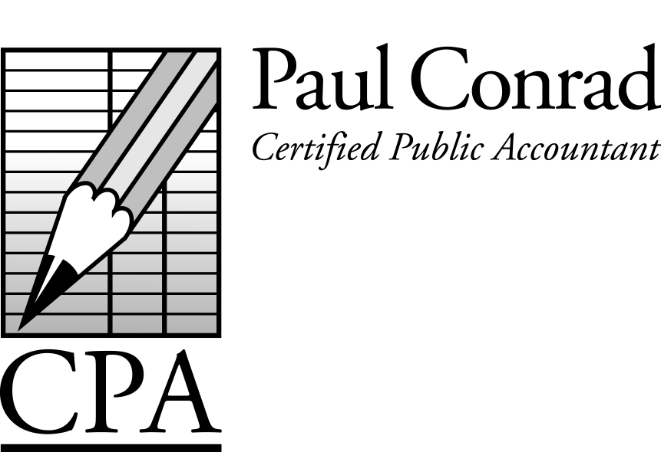

November 2016

Last Minute Tax-Planning Ideas

As the year comes to a close, here are some last minute tax planning ideas to consider:

Slow down your income – Don’t deposit your income (checks from clients) until January.

Speed up your expenses – Pay some expenses you’d normally pay in January in December instead. This could be business expenses or personal expenses (property taxes are common for this strategy).

Credit cards – Charging an expense in December gives a deduction this year, even if you pay the balance due next year.

Harvest your investment losses – Sell some investments that have lost money. You can deduct up to $3,000 of losses each year. If you have investment gains from earlier in the year, then sell enough investments with losses to offset those gains.

Hire family members – Family members in lower tax brackets could be considered for this strategy.

Purchase new assets – Many assets allow 100% depreciation in the year of purchase. Real estate and smaller vehicles don’t qualify (but small vehicles can still get a pretty good deduction).

Start a retirement plan – This is a good way to get a tax deduction if you were going to save money anyway. Retirement plans come in all shapes and sizes; there’s a good chance one of them is right for you.

Donate appreciated assets – Applies to assets that have increased in value that you’ve held longer than a year. Example: you bought a stock for $1,000 and its now worth $2,500. Give the stock to charity. You’ll get a $2,500 deduction and don’t have to declare $1,500 of income.
A Newsletter for Small
Businesses and Families

Management Fees

Many self-employed clients have a management company to pay salaries and health insurance, reimburse for medical expenses, or contribute to retirement plans. Don’t forget to pay your management fee from your operating company to your management company before the end of the year to be able to take those deductions in 2016. Call me before year-end to discuss this if needed.

Tax Planning Meetings

Most good tax-saving ideas require some action to be taken before the end of the year. If you are interested in a meeting or a phone call before the end of the year to 1) estimate your taxes, and 2) discuss tax-saving ideas, please let me know. I’d love the chance to discuss your pending taxes before the year is over.

Watch for my New Videos

I’ve recently recorded 6 videos on topics of interest to many of my clients. Watch for links on my website.

- Taxes for Self-Employed People
- ‘Bad’ Bucket 1 and ‘Good’ Bucket 2 Income
- How Social Security Works
- Tax Deductions – What Can I Deduct?
- Retirement Plan Tax Deductions
- Taxes for Rental Real Estate

New Due Dates for Tax Returns

Starting with the 2016 tax year, partnership tax returns will be due March 15 instead of April 15, and FBARs (technically called FinCEN 114s) will be due April 15 instead of June 30. Six month extensions will be allowed for both returns. If I’ve prepared your partnership of FBAR in the past, I’ll keep track of these dates for you. If you prepare your own returns, be mindful of these new due dates.

Standard Mileage Rate for 2016 = 54 cents/mile.

Have a tax question?
Call me at 281-841-2753, or email me at paul@paulconradcpa.com

Tax Calendar
Nov 15 – Oct payroll tax deposits due
Nov 15 – Texas Franchise tax returns ‘on extension’ due
Nov 20 – Sales tax deposits due (Texas)
Dec 10 – Property tax payments due (Calif)
Dec 15 – Nov payroll tax deposits due
Dec 20 – Sales tax deposits due (Texas)
Jan 15 – Dec payroll tax deposits due
Jan 20 – 4th quarter sales tax returns due (Texas)
Jan 31 – 4th quarter payroll tax returns due
Jan 31 – W-2s/1099s due to recipients
Jan 31 – 4th quarter sales tax returns due (Calif)
Jan 31 – Property tax payments due (Texas)

Did You Form Any New Companies?

Many new companies require a tax return even if you didn’t use it. Please let me know of any new companies you formed in 2016 so that I can track it and prepare any required returns or extensions. Thanks!

Happy Holidays

2016 has been an eventful year for us. We moved to a new home, and soon expect to be building out separate office space above our garage. Kara’s business and mine have continued to grow, and we give thanks to God for all His wonderful blessings. We pray the coming year for all our clients and friends will be filled peace, joy, and success.

PS: Our old home is for sale. Anybody interested in a newly-remodeled home, please let me know. I’ll make you a good deal!

4303 Lake Kemp Ct
Richmond, TX 77406

(New Address!)

Do I Have to Pay the Healthcare Penalty?

I’ve been asked this question a few times. An interesting article can be found at https://www.healthinsurance.org/faqs. Essentially the IRS can only use your refund (assuming you have a refund coming) to pay the healthcare penalty. They cannot lien bank accounts or wages to pay the penalty if you choose to not pay the penalty. If you choose this tactic, you might receive some nasty collection letters, so it’s not for the faint of heart, but certainly there seems to be a loophole in the wording of the law. Any unpaid penalty would continue to be assessed with interested added on.

So what happens if you owe taxes and the healthcare penalty, and you only pay the taxes? Will the IRS apply the payment to the penalty and then still try to collect the taxes? It is well established that the IRS applies payments to the oldest amount owed, and have publicly stated that when taxes and penalty are shown on the same return, then the taxes are considered as the oldest balance due. Sounds good so far. But, in theory the unpaid penalty becomes the oldest balance due in the next year, so partial payments may be applied to the unpaid penalty from the prior year.

I personally do not have any experience with clients who have tried this strategy, so I can only tell you what I hear and read. If you choose to take on the IRS over the healthcare penalty, I’ll help any way I can, but certainly cannot guarantee a certain result.

