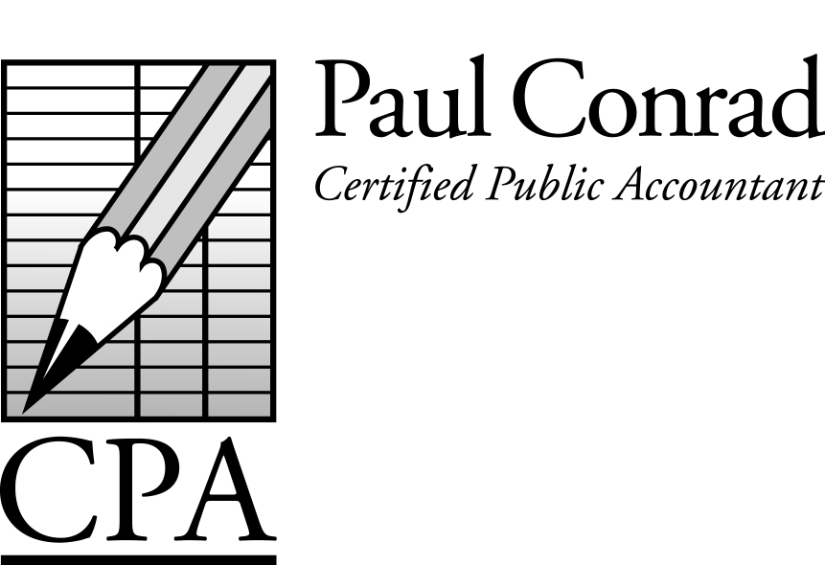

May 2016

‘Bad’ Bucket #1 and ‘Good’ Bucket #2

You may not realize this, but not all income is taxed the same. To help clarify this, I’ve come up with the phrase ‘Bad’ Bucket #1-type of income, and ‘Good’ Bucket #2-type of income. Here are the definitions:

‘Bad’ Bucket #1 – Income that is taxed for both income taxes and Social Security taxes. Examples include employees who receive W-2s (both income taxes and Social Security taxes are withheld from their paychecks), and sole-proprietorships/single-member LLCs (whose owners pay income taxes and Self-Employment tax on their earnings). This is the type of income most people earn.

‘Good’ Bucket #2 – Almost all other kind of income is taxed for income taxes, but NOT Social Security taxes. This includes interest, dividends, capital gains on stocks, bonds, mutual funds, ETFs, rental property profit, oil & gas royalties, pension plans, 401-Ks, IRAs, unemployment, alimony, Social Security, gambling winnings (if there is such a thing) and most importantly…distributions from a Subchapter ‘S’ Corporation or Limited Partnership to its owner(s).

If you own your own business, wouldn’t it be cool to form a Subchapter ‘S’ Corporation or a Limited Partnership and pay yourself ‘good’ bucket #2-type of income instead of ‘bad’ bucket #1-type of income? How much money could you save?

Retirement Plan Deductions

Looking for a way to shelter more income in a retirement plan than an IRA or 401-K? You might be a good candidate for an old-fashioned pension plan (called a Defined Benefit Pension Plan, or DB Plan for short). They’re not right for everybody, but for the right small-business owner or consultant, they are a wonderful way to get a tax deduction larger than IRAs and 401-Ks.

A Newsletter for Small
Businesses and Families

Why Form a Business Entity?

It’s been a while since I’ve written about the ‘why’s’ for creating a business entity for your own business. Here is a refresher:

Legal Protections – Sometimes in life things just go wrong. In business, you could have a claim/lawsuit brought against you by a customer, vendor, or employee. A properly formed entity gives your attorney one more tool to defend you. Just don’t negate the protections by co-mingling your business with other personal activities.

Tax Savings – Learning how to pay yourself is crucial to how much taxes you’ll be paying (see the article on ‘Bad’ Bucket #1 and ‘Good’ Bucket #2).

Reduced Audit Risk – The IRS audits personal returns more often than business returns. A business entity with a separate tax return allows you to remove your gross income and expenses from your personal return onto a business return. You just show the ‘net’ profit on your personal return – giving the IRS less to look at.

Legal protections and reduced audit risk, all while saving taxes! Call me for a free consultation.

Reporting Foreign Assets

The IRS continues to penalize taxpayers for not disclosing foreign bank accounts. They have also pursued foreign banks for not handing over customer lists of US citizens with foreign bank accounts. In a few instances the foreign bank was threatened with being blocked from doing business in the US. Left with no choice, those foreign banks ended up disclosing their US customers with foreign bank accounts…providing the IRS with many more US taxpayers to penalize.

The risk just isn’t worth it. If you haven’t already done so, you should start disclosing your foreign bank accounts now.

Have a tax question?
Call me at 281-841-2753, or email me at paul@paulconradcpa.com

Tax Calendar
May 15 – Franchise tax returns due (Texas)
May 15 – April payroll tax deposits due
May 20 – Sales tax deposits due (Texas)
June 15 – May payroll tax deposits due
June 15 – 2nd qtr estimated payments due
June 20 – Sales tax deposits due (Texas)
June 30 – Foreign bank account reporting due
July 15 – June payroll tax deposits due
July 31 – 2nd qtr payroll tax returns due
July 31 – 2nd quarter sales tax returns due (Calif)

Tax Return Fraud

ADP, the largest payroll processor in the US, and several of its clients, recently had a data breach that allowed fraudsters to access W-2 information of thousands of US taxpayers. ADP provides a service to its clients whereby a website is created that allows their clients’ employees to access their W-2s online. Fraudsters used stolen social security numbers and other personal information to create UserIDs and then download the employees’ W-2s. This is similar to last year when fraudsters used social security numbers and personal information to download Wage and Income Transcripts directly from the IRS. Even though no fraudsters actually accessed the ADP computers, this is a good example for all of us to be diligent in safeguarding our personal information.

Do You Know Where Your IRAs Are?

Recently a client was charged a penalty for not taking as much Required Minimum Distribution (RMD) from their IRAs as was required by law. They had IRAs at several different financial institutions…and just lost track of them all. The penalty was 50% of the RMD that should have been taken but wasn’t taken.

2238 Woodland Park Drive
Houston, TX 77077

Are They REALLY
Independent Contractors?

The IRS is continuing in its efforts to find companies that treat their laborers as independent contractors instead of employees. The temptation is certainly real…paperwork savings and payroll tax savings for the company. But those savings can be short-lived once the IRS comes knocking on your door (or when your independent contractor files an unemployment claim or a workers’ compensation claim, because they thought they were an employee all along). Don’t fall victim to the temptation!

Mexico Homebuilding Project

It’s not too late to donate to this year’s Mexico Homebuilding Project. Many of you know that Kara and I travel to Mexico each year to help build a home for a needy family chosen by Corazon Ministries. Besides building homes, Corazon also provides classes in construction, sewing, gardening, and other life-skills, and provides scholarships to elementary, high-school, and college students. If you are interested in helping this year, please a check to me, payable to Corazon Ministries. Thanks!

Vehicle/Mileage Expenses

A business-owner or an employee with unreimbursed mileage can use the ‘mileage’ method of deducting their vehicle expenses. For 2015 the IRS’ mileage rate was 57.5 cents/mile, and for 2016 its 54 cents/mile (lower fuel costs is the reason). But…you still have to keep track of the business miles driven. Estimating (guessing) won’t cut it. Several of my clients use an app and their smartphone to keep track of their mileage. A search on the internet would provide lots of options.

