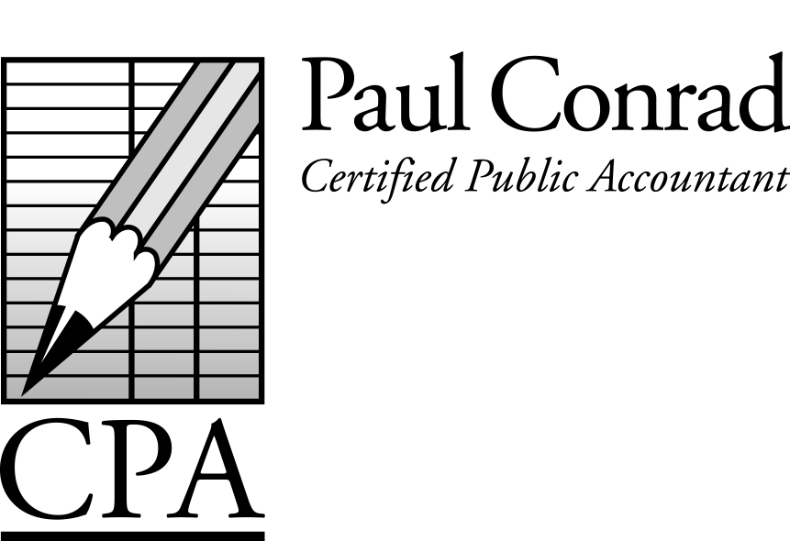

August 2016

Deductions for Retirement Plans

Many of my self-employed clients set up a Limited Partnership or Subchapter S Corp to minimize their social security / self-employment taxes. While everybody likes to minimize their taxes, this also makes deductions for retirement plans tricky.

An example might help: If you ever contributed to a 401K plan as an employee, you were allowed to do that because you had ‘earned’ income (income you also paid social security taxes). Conversely, if your only income was interest, dividends, rents, etc, then you wouldn’t be allowed to deduct a contribution to a 401K or IRA – because that type of income is ‘passive’ income. Ultimately, retirement plan deductions come from ‘earned’ income and not ‘passive’ income. So while we try to keep your ‘earned’ income as low as possible to minimize the social security taxes, we also want your ‘earned’ income to be as high as possible to maximize your retirement plan deduction. The goal is to balance the income tax savings from the retirement plan against the additional social security tax from the ‘earned’ income.

For lack of space I can’t go into all the details of each kind of retirement plan, but just know that they all have advantages and disadvantages. Some allow large deductions, but trigger a lot of social security taxes at the same time. Others allow smaller deductions, but trigger a smaller amount of social security taxes. Some plans you want to avoid completely, since they trigger a lot of social security taxes and still don’t allow much of a deduction.

I’ll be glad to have a detailed conversation with you about retirement plans. Just give me a call.
A Newsletter for Small
Businesses and Families

Credits and Deductions for College

College is expensive, so don’t miss out on the tax savings!

529 Plans - Many people save for their kids’ college through 529 Plans. The earlier you start the better, because the earnings of 529 Plans is not taxed if you spend the money on college expenses. However, any time you withdraw money from a 529 Plan, you have to disclose that withdrawal on your tax return (even though it’s not taxed). If you don’t disclose the withdrawal, then the IRS will require you to pay taxes on it. Be on the watch for Form 1099-Q when you withdraw money. Room and board is a qualified expense for 529 Plans.

Tuition Credit – This credit (a direct reduction of your tax bill) can save you up to $2,500 in taxes, if you spend $4,000 on college expenses. You get a 100% credit for the first $2,000 in college expenses, and an additional 25% credit for the next $2,000 in college expenses. This applies to full-time students, and the credit can apply to more than one student. This credit also has an income limit. Room and board is NOT a qualified expense for this credit. Watch for Form 1098-T.

Strategy: You can’t pay for college expenses with withdrawals from a 529 Plan AND take the Tuition Credit on the same expenses. However, you can split your college expenses between the two. For example, it might save the most taxes to use the Tuition Credit for the tuition costs, and use the 529 Plan to pay for the room and board.

Small credits and deductions are allowed when the student is not a full-time student or when income limits apply.

Have a tax question?
Call me at 281-841-2753, or email me at paul@paulconradcpa.com

Tax Calendar
Aug 15 – July payroll tax deposits due
Sept 15 – Business returns ‘on extension’ due
Sept 15 – Aug payroll tax deposits due
Sept 15 – 3rd qtr estimated payments due
Sept 20 – Sales tax deposits due (Texas)
Oct 15 – Personal returns ‘on extension’ due
Oct 15 – Sept payroll tax deposits due
Oct 20 – 3rd quarter sales tax returns due (Texas)
Oct 31 – 3rd quarter payroll tax returns due
Oct 31 – 3rd quarter sales tax returns due (Calif)

A Good Time to Convert to a Roth IRA?

When is a good time to convert your traditional IRA to a Roth IRA? The answer: when you are in a low tax bracket. If your income is low, or you are currently unemployed, now might be a good time to convert. Most of my clients live in Texas, and many of them are in the oil/gas professions, and (unfortunately) many of them are looking for work. Why not take advantage of the situation when your earnings are low (or you’re out of work) and convert some of your IRA into a Roth IRA. Yes, the extra taxes now will hurt, but it might save you a lot more taxes later on.

It’s (Almost) Too Late

Business returns (partnerships, ‘S’ corporations, and trusts) that were put on extension earlier this year will have their extensions expire on Sept 15. Penalties for being late are $195 per owner per month. If you still haven’t prepared that return, you’d better hurry.

4303 Lake Kemp Court
Richmond, TX 77406
(new address!)

What is the Mission of Your Business?

Recently I read a book about why so many small businesses go out of business. Part of the reason is that the owners don’t have a clearly defined mission for their business. Something that brings them joy and purpose, and keeps them focused on the mission. I thought about that for a while…exactly WHY am I in business? After much thought, here’s what I came up with: To help people live a better life, by showing them how to save money on their tax bills, and then to encourage them to save/invest their savings, so that they enjoy the freedom that comes when their future finances are in order.

Do you need someone to discuss your saving and investment plan (do you have a saving and investment plan)? Need a referral for a financial planner, investment advisor, or estate planning attorney. Please give me a call. I’d love to help.

Another Successful Mexico
Homebuilding Project

In May our family participated in our 9th Mexico Homebuilding Project through Corazon Ministries. Normally in October, we moved the project to May this year so that our kids could join us (never too early to teach kids the benefits of helping others). We crossed the border into Tijuana, built the home for a needy family, and crossed the border back into the US in one looooong day! Many thanks to all the clients who helped finance the project, and to the 20+ California volunteers who helped build the home.

