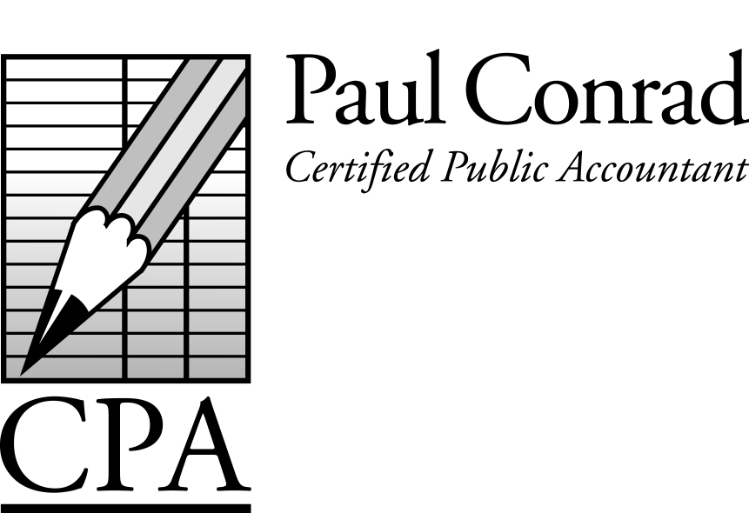

November 2015

Reduce Your Chance of Being Audited

If you own your own business, you can operate as a Sole-Proprietor, or can form a formal business entity, such as a Corporation, Subchapter ‘S’ Corporation, or Limited Partnership, through the Secretary of State in your home state. There are three reasons for form a formal business entity:

- Tax-Savings
- Legal Protections
- Reduced Audit Risk

What does ‘reduced audit risk’ mean? A sole proprietorship that uses Schedule C (a separate schedule attached to your personal tax return) is audited 1%-5% of the time (sometimes more) depending on the amount of income and the amount and type of expenses listed. A separate business return with the same income and expenses is audited only .4% of the time. I have no idea why the IRS publishes that statistic…but they do. Not that this opens the door to cheat on our taxes, but who wants to go through the hassle of an audit? In the past year I had 3 Sole-Proprietorships that were audited (2 of them showed losses), and while we generally ‘won’ the audit, the client still had to pay me for the time to defend them. If you own your own business, and want to reduce the chance of an audit, then you should form a formal business entity for your business.

IRS Continues to Focus on
Independent Contractors

Many companies continue to treat valid employees as independent contractors. Avoid the temptation to treat your employees like independent contractors. You might be saving some payroll taxes and/or paperwork, but if the worker files an unemployment claim (‘I didn’t know I was an independent contractor’) or gets hurt on the job, you could end up with a big, expensive problem on your hands.
A Newsletter for Small
Businesses and Families

Management Fees

Many of my clients in business for themselves have a management company to pay salaries and health insurance and reimburse for medical expenses. Don’t forget to pay your management fee from your operating company to your management company before the end of the year to be able to take those deductions in 2015. Call me before December 31 to discuss this if needed.

Kids as Employees or Owners

Many family-owned businesses hire their kids as employees or give them a small ownership % of the family business, and this can be a large tax savings for the family. However, this is not a tax strategy to approach in a hap-hazard fashion. The kids really should perform some meaningful work and should be paid a realistic wage (Yes, you do actually have to pay them, and No, a 14-year-old shouldn’t be paid $50,000+ for a part-time job over summer break). If the kids are in college, they should be paid a wage and should pay the tuition themselves (avoid the easy way out by paying the tuition yourself and then retroactively calling it a salary).

Mexico Homebuilding Project

Last month Kara and I traveled to Tijuana, Mexico for the 8th time to build a home-in-a-day for a needy family. This year the home went to the Valenzuela family. They got on the ‘list’ to receive a home by going through construction classes, sewing/gardening classes, and volunteering to build homes for other families on the list ahead of them. What was especially heart-warming about the Valenzuela family was once they reached the top of the list, they consistently gave their spot on the list to other families who needed a home more than they did. I’m glad they finally got a home of their own. We couldn’t have done it without the financial support of many clients and friends. I’d like to thank everyone for their support (you know who you are)!

Standard Mileage Rate for 2015 = 57 ½ cents/mile.

Have a tax question?
Call me at 281-841-2753, or email me at paul@paulconradcpa.com

Tax Calendar
Nov 15 – Oct payroll tax deposits due
Nov 15 – Texas Franchise tax returns ‘on extension’ due
Nov 20 – Sales tax deposits due (Texas
Dec 10 – Property tax payments due (Calif)
Dec 15 – Nov payroll tax deposits due
Dec 20 – Sales tax deposits due (Texas)
Jan 15 – Dec payroll tax deposits due
Jan 20 – 4th quarter sales tax returns due (Texas)
Jan 31 – 4th quarter payroll tax returns due
Jan 31 – W-2s/1099s due to recipients
Jan 31 – 4th quarter sales tax returns due (Calif)
Jan 31 – Property tax payments due (Texas)

Healthcare Update – Part 1

2014 was the first year that taxpayers without qualified health insurance potentially paid a penalty. The penalty is based on your income and the number of family members, and usually ranged from $300 to $1,500. The penalty is scheduled to increase for 2015 and future years. Starting in 2015, taxpayers will have to prove their insurance coverage by providing their tax preparer with a new Form 1095, given to them at year-end by their insurance company or employer. In other words, when I ask you if you had health insurance in 2015, you’ll have to provide me with the Form 1095 as proof.

Healthcare Update – Part 2

Almost one million taxpayers had to repay part/all of their insurance subsidy because their actual income was more than their estimated income when they purchased insurance from the Marketplace, or because they didn’t file a tax return. Be as accurate as possible when you estimate your future income to avoid having to repay the insurance subsidy, and make sure you file a tax return.

2238 Woodland Park Drive
Houston, TX 77077

Roth IRAs for Kids & Grandkids

A one-time contribution of $5,500 for a 16-year-old, growing at 7%/year, will reach $151,000 at age 65, or $212,000 at age 70. $5,500 contributed starting at age 12 for five consecutive years (total contributed = $27,500) will grow to $1 million at age 70. After age 59 ½, Roth distributions are tax-free.

New Due Dates for Tax Returns

Starting with the 2016 tax year, partnership tax returns will be due March 15 instead of April 15, and FBARs (technically called FinCEN 114s) will be due April 15 instead of June 30. Six month extensions will be allowed for both returns.

Tax Planning Meetings

Most good tax-saving ideas require some action to be taken before the end of the year. If you are interested in a meeting or a phone call before the end of the year to 1) estimate your taxes, and 2) discuss tax-saving ideas, please let me know. I’d love the chance to discuss your pending taxes before the year is over.

Did You Form Any New Companies?

Many new companies require a tax return even if you didn’t actually use it. Please let me know of any new companies you formed in 2015 so that I can track it and prepare any required returns or extensions. Thanks!
-----------------------------------------------------------
I constantly have clients ask me ‘Can I write this off on my tax return?’ For the best answer I’ve heard, go to www.youtube.com/watch?v=XEL65gywwHQ (it’s a Seinfeld episode).

