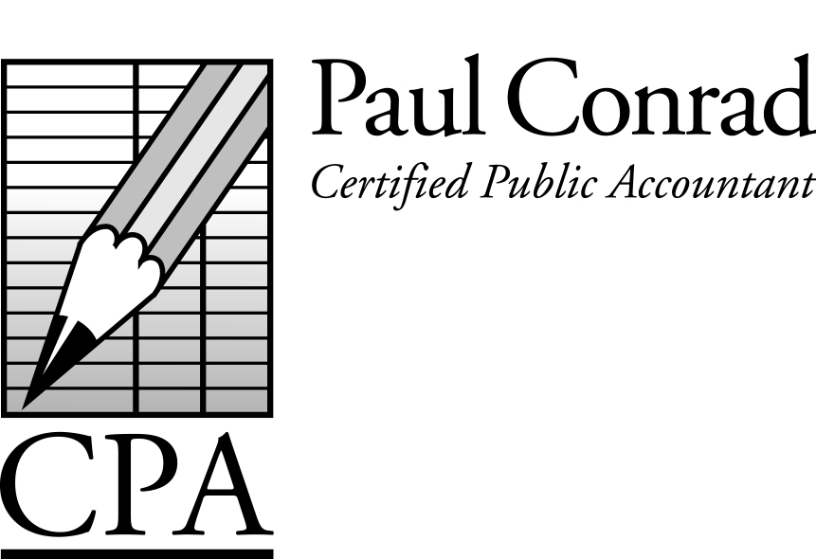

March 2014

Foreign Bank Account
Reporting has Changed

Many taxpayers own foreign bank accounts and foreign stock brokerage accounts, and over the past several years our government has stepped up their scrutiny of these types of accounts, for two reasons. Firstly, illegal activities are many times funded by these types of accounts, and secondly, taxpayers use these types of accounts to hide income from the IRS.

Regarding the first reason, the purpose of the Patriot Act and other laws is to give our government additional tools to fight crime. We could have a discussion about the right of our government to impose these types of laws for a common good (our own defense against foreign countries, terrorists, drug dealers, etc) versus our rights as private citizens to keep our affairs private and away from the prying eyes of our government. I won’t address those issues in this newsletter.

Regarding the second reason, many taxpayers use these types of accounts to hide income from the IRS. However, tax law requires US taxpayers to declare ALL their income, no matter where in the world it was earned (the US is one of the few countries that do this). If those same earnings are taxed in the foreign country too, there is a foreign-tax-credit to avoid double taxation.

Ultimately, foreign bank accounts require two types of disclosure. 1) Disclosure of the earnings on an income tax return, and 2) Disclosure of the balance in the account to crime enforcement agencies.

The penalty for not disclosing income is an assessment of the tax, plus penalties and interest. The penalties and interest could add as much as 40% more to the taxes that were owed.

The penalty for not disclosing the balance in the account to law enforcement agencies is 50% of the balance in the account. You can see that not reporting a foreign bank
A Newsletter for Small
Businesses and Families

account for only two years could mean forfeiting the entire balance. Personally I don’t think it’s worth it.

In past years, tax preparers would prepare a form, usually along with their clients’ tax return, that disclosed the foreign bank accounts (known as the FBAR, or TDF 90-22.1). That form was mailed to a special IRS office in Detroit, Michigan. I have a feeling that the IRS was just the collection point, and these disclosures were passed on to other US agencies. This process has changed for reporting 2013 foreign accounts, as the IRS is no longer involved.

From now on, foreign bank accounts are reported to the Financial Crimes Enforcement Network (FinCEN), and can only be reported electronically using FinCEN Form 114. The due date to report these accounts is still June 30 of each year for the prior year, with no extensions allowed. Taxpayers can file FinCEN Form 114a allowing another representative (tax return preparer) to file the Form 114 on their behalf. I’m still getting educated on this new reporting process, and my intent is after tax season to offer this service to clients.

‘Red Flags’ That Trigger Audits

The chances of being audited are less than 1% for taxpayers earning less than $100,000, up to 11% for taxpayers earning $1,000,000 or more. But there are some activities/deductions that can trigger an audit.

- Claiming 100% business use of a vehicle.
- Meals, travel & entertainment expenses deducted on Schedule C. These expenses require more support than other deductions.
- Hobby losses disguised as business losses. You should be able to prove your intent to make a profit. Especially true when you have a large income elsewhere on your return.
- Claiming to be a real estate professional and deducting real estate losses. Real estate professionals generally spend 750 hours/year on real estate activities (other businesses require 500 hours/year).
- Businesses that deal primarily in ‘cash’, since cash is easy to hide.
- Failing to report foreign bank accounts.
- Higher-than-average deductions.

Tax Calendar
Mar 15 – Corporate income tax returns due.
Mar 15 – Feb payroll tax deposits due.
Mar 20 – Sales tax deposits due (Texas).
Apr 1 – Property tax renditions due (Calif).
Apr 10 – Real estate taxes due (Calif).
Apr 15 – Partnership and personal inc tax returns due.
Apr 15 – 1st estimated payment for 2013 due.
Apr 15 – Mar payroll tax deposits due.
Apr 15 – Property tax renditions due (Texas).
Apr 30 – 1st quarter payroll tax returns due.
Apr 30 – 1st quarter sales tax returns due.
May 15 – Franchise tax returns due (Texas).
May 15 – Apr payroll tax deposits due.

Simplified Home-Office Deduction

Instead of keeping track of all your actual home-office expenses, you can deduct $5/square foot, up to 300 feet of office space in your home.

Paper or Electronic Newsletter

I’ll be glad to send you an electronic version instead of a printed version if you prefer. Just let me know.

Should You Pay Off Your Mortgage?
(a continuation of a previous article)

Financially it might not make sense to payoff a low-interest rate mortgage if you can earn a higher return on your investments. Emotionally you might want to payoff your mortgage as you get older. Why not set up a separate bank account and deposit the money you would have used to payoff the mortgage? That way, you could payoff the mortgage if you want, but you still have access to the money (for health costs, etc) if needed.

2238 Woodland Park Drive
Houston, TX 77077

Have a tax question?
Call me at 281-841-2753, or email me at paul@paulconradcpa.com

Fake IRS Emails and Phone Calls

The IRS’ stated policy is to only correspond with taxpayers by letter. If you receive an email or a phone call from someone claiming to work for the IRS, do not respond (especially if they claim you owe back taxes and offers to take your payment by credit card). Never open any attachments to an email supposedly from the IRS.

Dependent Deductions

You can claim a dependent deduction for anybody (kids, parents, other relatives, etc) that you provided more than ½ of their support, and they earned less than $3,900. If the dependent is a college student under 23 years old, they can earn over $3,900. If you plan on declaring a dependent, make sure they haven’t already claimed themselves as a dependent on their own return.

Credit Card Statements Proof of Payment

How does the IRS know a charge to a local restaurant, treated like a business expense, is not really a couple going out for Valentine’s Day? For this reason, many deductions require additional information, such as the people present and the reason it’s a business deduction.

‘What Do You Need From Me?’

This is usually the first question a client asks me when it’s time to prepare their tax return. Prior year tax returns are good. I’ve also included a Tax Planner Checklist to help out.

