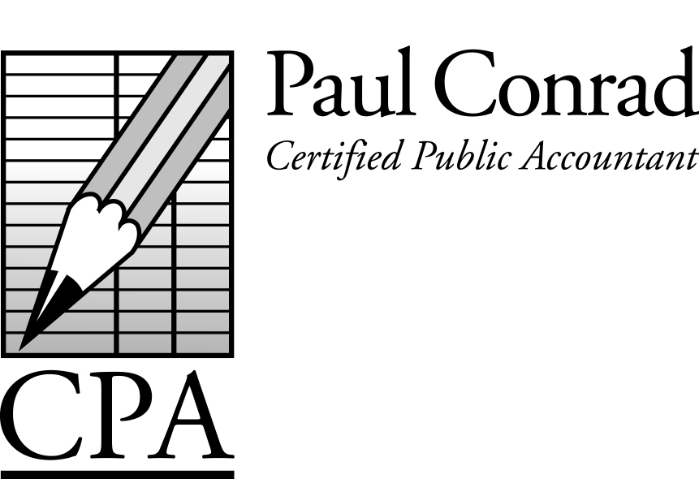

June 2014

A Tough Tax Season

This past tax season, more than any tax season in recent history, I had more difficult conversations with clients about the balance due on their tax return. We all knew that, for many people, taxes had gone up. But I don’t think most people were prepared for how much they went up. What were the reasons for being surprised?

Tax rates went up. The top tax rate increased from 35% to 39.6%, almost 5% higher.

Two new taxes were added: Medicare tax - For single people with wages exceeding $200,000, an extra .9% Medicare tax was added. Most employers withheld this extra tax from your paychecks, so it didn’t affect their tax return. But what about a husband + wife who have combined wages exceeding $250,000 (the cutoff for married people)? For example, both husband and wife earn $175,000, so no extra Medicare tax is withheld by their employers, but when they file their tax return, they have to pay .9% extra tax on the amount over $250,000.

And the Net Investment Income tax – Earnings from interest, dividends, rents, royalties, capital gains, and passive investments have an additional 3.8% tax when total earnings exceed $250,000. The same husband + wife above, who had $250,000 of wages, and also earned $50,000 in capital gains from a strong stock market, which triggered the additional 3.8% tax.

Itemized Deductions are Limited – In previous years you deducted all of your property taxes, mortgage interest, church/charitable donations, and several other deductions. Starting in 2013, those same deductions were ‘phased-out’ as your income increased. You could lose as much as 80% of those deductions now.

And so are Personal Exemptions – In previous years this deduction was worth $3,900 for each person listed on your return, but just like Itemized Deductions, the

A Newsletter for Small
Businesses and Families

Personal Exemptions are ‘phased-out’ as your income increases, eventually being completely phased-out.

One client was even surprised after telling his Human Resources Dept to deduct the maximum amount of taxes from a bonus he received. As we researched the reason for his balance due, we found out that the HR Dept was using the ‘old’ maximum rate of 35% and not the ‘new’ maximum rate of 39.6%.

If you haven’t had your 2013 tax return prepared, you might want to mentally prepare yourself for a surprise.

Foreign Bank Accounts

Taxpayers with foreign bank accounts must report any accounts with $10,000 or more (in US dollar equivalent) at any time during the year to our Federal government. In prior years, a separate ‘tax’ form was prepared and mailed to an IRS office in Detroit, Michigan. The foreign bank account does not trigger any additional taxes, but is a disclosure requirement, and was used by the Federal government to enforce other laws, particularly foreign bank accounts that fund terrorist, drug, financial and other crimes. The due date of the form is June 30 of each year (separate from the due date of your tax return). The penalty for not reporting foreign bank accounts is 50% of the balance of the account.

The process is now different. The form is now called FinCEN Form 114 (Financial Crimes Enforcement Network) and can only be prepared and reported online. The due date and penalties are still the same. Although not technically a ‘tax’ form, my tax software will soon release an update to allow me to prepare the FinCEN Form 114 for you, and electronically send it in. You will need to sign FinCEN Form 114a, which allows me to file the FinCEN Form 114 for you. In the coming weeks I will be learning this new process.

If you have a foreign bank account, please be aware of the June 30 due date, and contact me for help.

Have a tax question?
Call me at 281-841-2753, or email me at paul@paulconradcpa.com

Tax Calendar
June 15 – May payroll tax deposits due
June 15 – 2nd qtr estimated payments due
June 20 – Sales tax deposits due (Texas)
June 30 – Foreign bank account reporting due
July 15 – June payroll tax deposits due
July 20 – 2nd quarter sales tax returns due (Texas)
July 31 – 2nd quarter payroll tax returns due
July 31 – 2nd quarter sales tax returns due (Calif)
Aug 15 – July payroll tax deposits due.

IRS Tax Tips

The IRS offers a nifty email service that automatically emails you with helpful hints for preparing, filing and paying your taxes. It’s easy to read, with tips on what income to report, tax deductions and credits available, how to pay your taxes, and what to do if you can’t pay your taxes. Go to http://www.irs.gov/uac/Subscribe-to-IRS-Tax-Tips-1 to subscribe.

Corazon Homebuilding Project

Included with this newsletter is a fundraising letter about Corazon Ministries. Corazon is near and dear to my heart, and Kara and I have been involved with Corazon for many years. Occasionally you hear about non-profits that abuse their tax exempt status (high salaries and benefits to the employees, with very little of your donations actually being used for the charitable mission). After many years of involvement I can assure you that is not the case with Corazon. Please consider donating to Corazon this year!

2238 Woodland Park Drive
Houston, TX 77077

Please see the Corazon
Homebuilding letter inside!
Healthcare Penalties

Most people know that if you don’t have healthcare, you will be charged a penalty. The amount most heard in the news is $95 for a single person. However this is not all the details. For 2014, the penalty is the GREATER of $95 or 1% of your taxable income. The $95 increases to $325 in 2015 and $695 in 2016. The 1% of taxable income increases to 2% in 2015 and 2.5% in 2016.

I’ve heard several people tell me they’ll just pay the penalty. However, this will become a more expensive decision in future years. How expensive? The Tax Policy Center has created an online calculator to estimate the penalty for you, which can be found at http://.taxpolicycenter.org/taxfacts/acacalculator.cfm.

Using this online calculator, I plugged in a single person earning $40,000. The penalty would be $299 in 2014, $650 in 2015, and $1,390 in 2016. When I plugged in a family of 4 earning $120,000, the penalty ends up being $997 in 2014, $2,060 in 2015, and $2,655 in 2016.

Perhaps you are fairly healthy and don’t feel you need health insurance, but nobody knows when accidents happen. I know a person who is healthy, but was involved in a car accident. Even though it was the other driver’s fault, the other driver was uninsured, and the medical bills exceeded $200,000. I’d encourage everyone to find healthcare they can afford.

*****
‘The wages of sin are death, but by the time taxes are taken out, it’s just sort of a tired feeling’. – Paula Poundstone.

